1. My previous employer, Xante, made printers that were typically used to print large mailings. I was responsible for writing services that applied changes to recipient addresses and pre-sorted said mailings for delivery. Doing these things through a licensed vendor allowed our customers to receive discounts from the US Postal Service (USPS) on their mailings.

Like any project, that project had its share of technical hurdles. It was the first time I had dealt with web services and WCF. The materials provided by USPS had their share errors; I actually had to add logic to detect and correct errors in one of the wsdl files they provided. The logic for looking up recipient address changes was partially specified in COBOL provided by USPS. Rather than figure out the COBOL, I actually used GnuCobol to compile the USPS source to C, and then turned said C into a dll that could be incorporated into our .Net solution.

Of course, every project I’ve ever been on has had its share of technical hurdles. What really set this project apart from others was that I was responsible for all of the non-technical pieces as well, and this required me to develop some skills that don’t necessarily get called on writing software. I had to apply for a number of USPS licenses. This meant finding and applying relevant documentation as well as working with various USPS personnel to certify our services. I had to learn who knew what at USPS, and then I had to work hard to get and stay on their good sides. Sometimes that meant talking about their husband’s health issues for 15 minutes before asking a question. It sounds folksy, but one of those relationships saved me from having to submit to a second certification and incurring a $1000.00 fee.

Another accomplishment, from that project, that I am proud of was a security plan that had to be approved by USPS. The plan explained how Xante would protect a ledger of people’s changed addresses. The entire plan was about a page long (with diagrams) and basically said that sensitive resources would be kept behind a firewall and locked door. I had never done anything like that before, and It would have been natural to make something complex and highly detailed. However, Xante was a small operation. We didn’t have a dedicated security officer or any personnel with serious expertise in cyber security. Changes to the plan would have to be submitted for approval, and deviating from the plan would result in penalties. As such, I made sure that my boss understood and agreed with the plan being as simple and non-committal as possible. I also made sure he understood the deadlines we would face if an audit found us lacking. We submitted early to allow time to redevelop and resubmit if needed, but the plan was approved on the first submission. I am proud of this because the plan we developed was what was best for the company, and the amount of time spent to generate what was needed was minimal.

I could go on talking about that project. During its execution, there were a number of other accomplishments of which I am proud. However, I wanted to keep my answer to a single page. I hope this old war story paints a good picture of the kind of person I am. I hope that kind of person is someone you think is worth hiring.

1. I just started reading *The Visual Display of Quantitative Information* by Edward R. Tufte. The analytics folks in the office in my office have been passing it around, so I decided to see what all of the fuss was about. There are three basic functions that a UI has to facilitate with respect to data: search/selection, entry/modification, and analysis. I’d recommend this book to anyone developing applications for data analysis.
2. Availity basically helps healthcare providers submit insurance claims and get their money…They sound similar to the SSI Group.
3. I opted to use Java for this exercise. The complete NetBeans solution is in “Question 4 Coding Solution.zip”, located in the same directory as this document. All of the logic specified was implemented in “Main.java”. The contents of this file are shown below for your convenience.

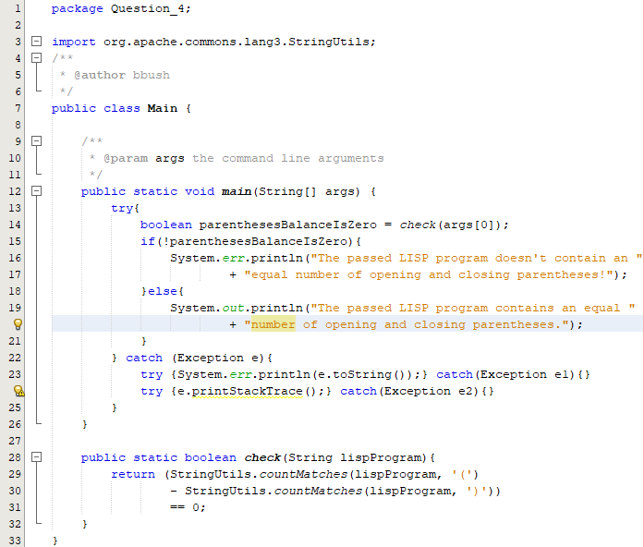

1. I opted to write a Bash script for this exercise. I decided to use shell script because the task given was extremely simple and could easily be implemented with a very small amount of shell. Had the exercise offered any real-world complexities, I might have chosen something else. The actual script file (and a copy of my testing inputs and outputs) can be found in “Question 5 Coding Solution.zip”, located in the same directory as this document. The contents of the script file are shown below for your convenience.

